**Why sequence models are useful?**

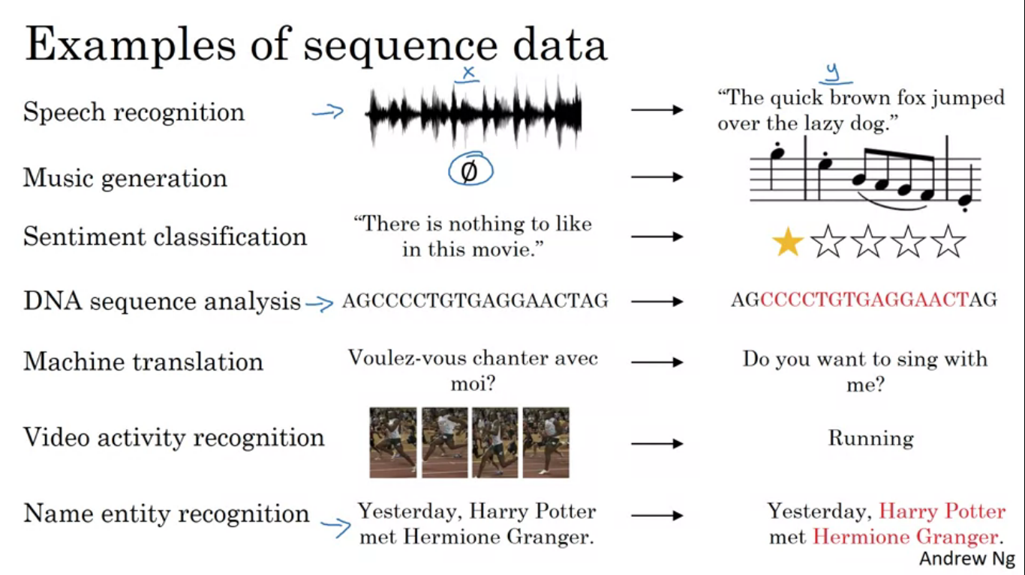

In speech recognition we are given an input audio clip X and asked to map it to text transcript Y. Both the input and output here are sequence data. X is a audio clip that plays out over time and Y is a sequence of words. So sequence models have been very useful for speech recognition. Music generation is another example of a problem with sequence data. In this case only the output Y is a sequence, the input can be empty set or can be single integer referring to the genre of the music you want to generate.

In sentiment classification input X is a sequence and output is the emotion result.

Sequence models are also very useful in DNA sequence analysis. DNA is represented by 4 alphabets A, T, C, G. So given a DNA sequence can you label which part of the DNA sequence corresponds to a protein.

In machine translation we have an input sentence and the output is the translation in different language.

In video activity recognition, we might be given a sequence of video frames and asked to recognize the activity.

Named Entity recognition given a sentence and identify the people in that sentence.

All of these problems can be addressed as supervised learning with label data X,Y as the training set. In some both X and Y are sequences and sometimes X and Y have different lengths or in some examples only sequence X or the output Y is a sequence.

**Recurrent Neural Network Notation**

Let’s say we want to build a sequence model to input a sentence, and we want our sequence model to automatically tell us where are the peoples names in this sentence. This is called as named entity recognition and is used by search engines. Named entity recognition can be used to find people names, company names etc in different types of texts. We want a model to output Y that has 1 output per input word and the target output and the desired Y tells us for each of the input words is that a part of a person’s name.

Input is a sequence of 9 words, so we are going to have 9 sets of features to represent these 9 words. To index the words we use X<1>, X<2>, ...., X<9>. For the outputs Y<1>,Y<2> ,..., Y<9>.

Tx = length of input sequence, Ty = length of output sequence.

To refer to Tth element in the sequence of training example we denote by X(i)<t> . tx is the length of a sequence then different examples in training set have different lengths so txi would be the input sequence length for training example i.

Y(i)<t> means the Tth element of the output sequence of ith training example and TYI will be the length of output sequence in the i training example.

**How to represent individual words in a sequence?**

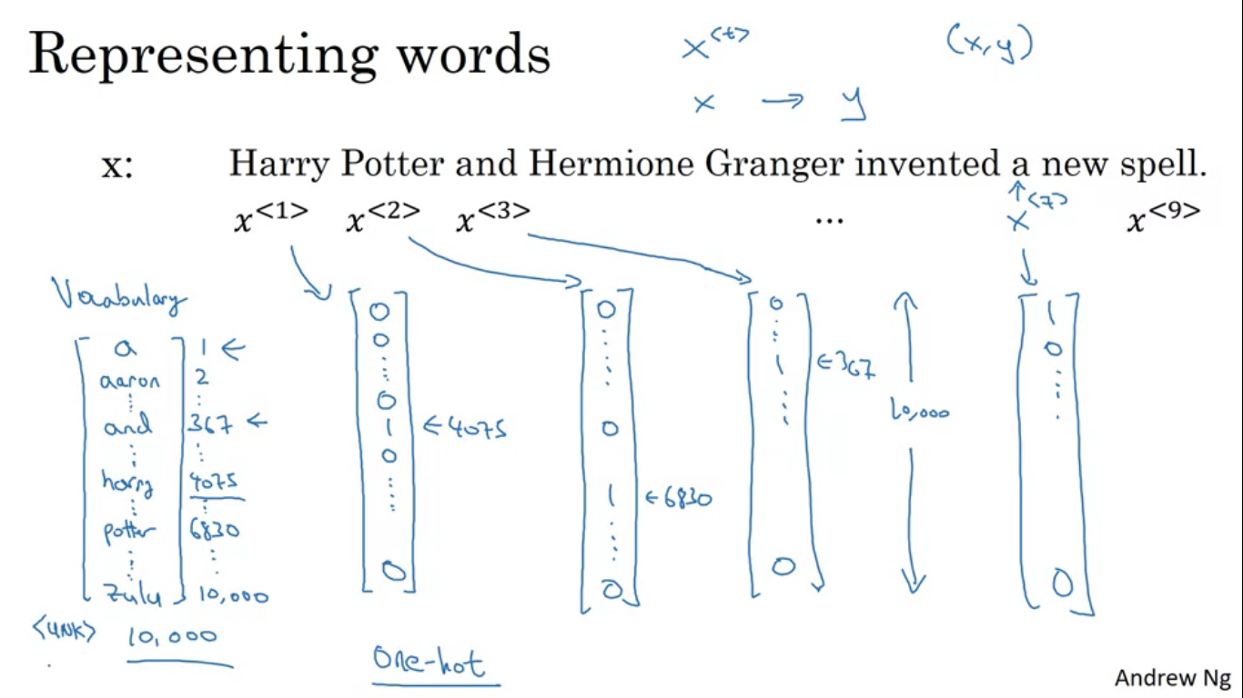

To represent words in a sentence, first we come up with a vocabulary. This means making a list of all the words we will use inn representations. We have a dictionary/vocabulary of 10000 words. One way to look through this dictionary will be by looking over our training sets and find the top 10000 occurring words.

We can use one hot representation to represent each of these words. So x<1> which represents the word harry will be a vector with all zero except for 1 in the position of harry in the dictionary. Similarly for X<2>, all are 0 except for the position of potter. Each of the one hot would be a 10000 dimensional vector as our vocabulary has 10000 words.

Goal is given this representation for X to learn a mapping using a sequence model to then target output Y and we do this supervised learning algorithm with both X and Y.

**Recurrent neural network model**

We could try to use a standard NN for this task. We could feed in 9 one hot vectors and feeding them into a standard NN, after a few hidden layers and have this output nine values 0 or 1 to tell you whether each word is a part of a person’s name. This turns out not to work well because of two main problems-

Input and output can be different lengths in different examples. So not every single example had the same input length Tx or the same output length Ty.

Naive NN like this does not share features learned across different positions of texts.

It would be really good if harry appearing in starting positions is recognized as a name and when the same name appears somewhere later in the text, the NN can determine this is the person’s name. This is similar to CNN where we want things learned for one part of the image to generalize quickly to other parts of the image. We would wan similar effect for sequence data as well. Using a better representation lets us reduce the number of parameters in our model. This simple NN will have an extremely large input layer each x<i> is 10000 dimensional and there are many number of words so the weight matrix of the first layer will end up having an enormous number of parameters.

**What is a Recurrent Neural Network (RNN)?**

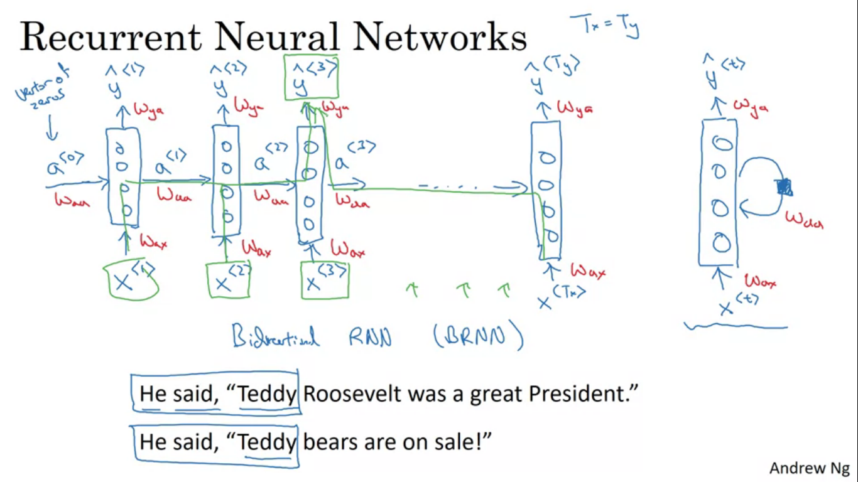

If we are reading the sentence from left to right, let the first word read is X1, we take the first word and feed it to the NN layer. We can have the NN predict the output .

What a RNN does is when it goes on to read the second word in a sentence, instead of just predicting Y2 using X2, it also gets to input what we had computed in time step 1. So activation value from time step 1 is passed on to time step 2. Then at the next time step, RNN inputs third word X3 and outputs Y3 up until the last time step where it inputs Xtx and outputs Yty. At each time step the RNN passes on its activation to the next time step for its use. To start the computation we also have some either made up activation at time 0 usually the vector of zeros.

RNN scans through the data from left to right and the parameters it uses for each time step are shared. The parameters governing the connection from X1 to the hidden layer will be some set of parameters Wax, the same parameter Wax is used for every time step. Similarly the other parameters include Waa,Wya. So in prediction of X3 it not only uses X3 but also uses information from X1 and X2 since it can pass through as shown in green.

One weakness of RNN is that it only uses information that is earlier in the sequence to make a prediction. So in predicting Y3 it does not consider the words X4,X5 and so on. This is a problem because in order to decide whether the word is a part of person’ name it would be useful to know information not from just first two words but also information from the later words in the sentence.

The limitation of this particular implementation is that the prediction in a time uses information from the inputs earlier in the sequence but not information later in the sequence.

**Forward propagation**

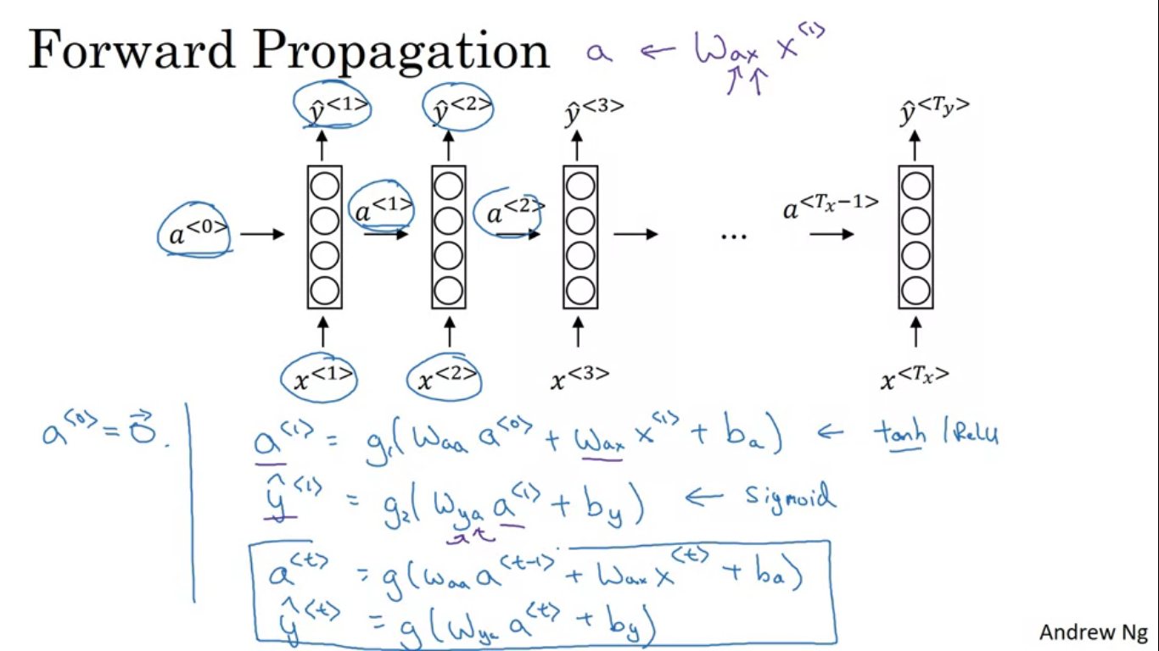

The process as images is shown.

The activation function used is tanh/ReLu in a<1>. For y<1> either sigmoid or softmax for the classification problem.

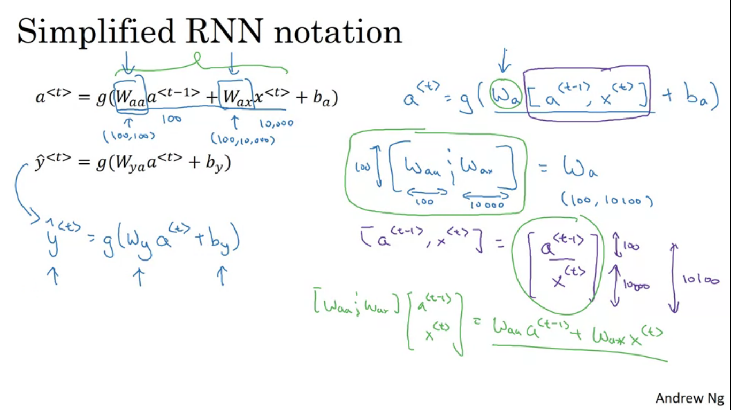

Wa is defined as horizontal stack of Waa and Wax.

If a is 100 dimensional and x was 10000 dimensional, then Waa would have been (100,100) matrix and Wax would have been (100,10000) dimensional matrix. So stacking these matrices horizontally, so Wa will be a (100,10100) dimensional matrix. Then a and x vector are stacked together vertically so this ends up being 10100 dimensional vector.

**Back Propagation through Time**

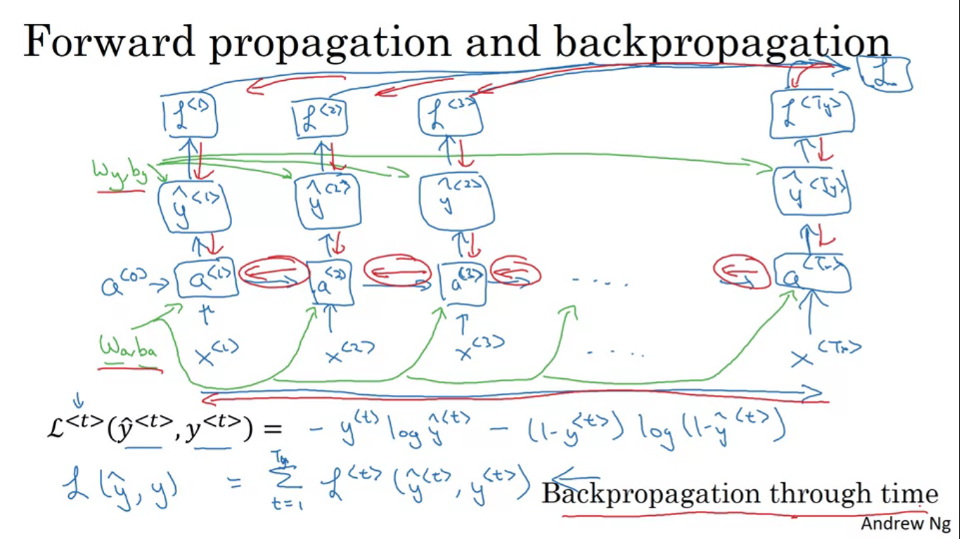

First define an element wise loss which is standard logistic regression loss also called as cross entropy loss.

This is the loss associated with a single prediction at a single position or at a single time set t for a single word. Total loss will be sum of the individual per time step losses. Back propagation is doing computations in opposite directions. In back propagation the computation goes from right to left. Forward propagation is going from left to right in increasing indices of time whereas for BP we are going from right to left going backwards in time.

**Different types of RNN**

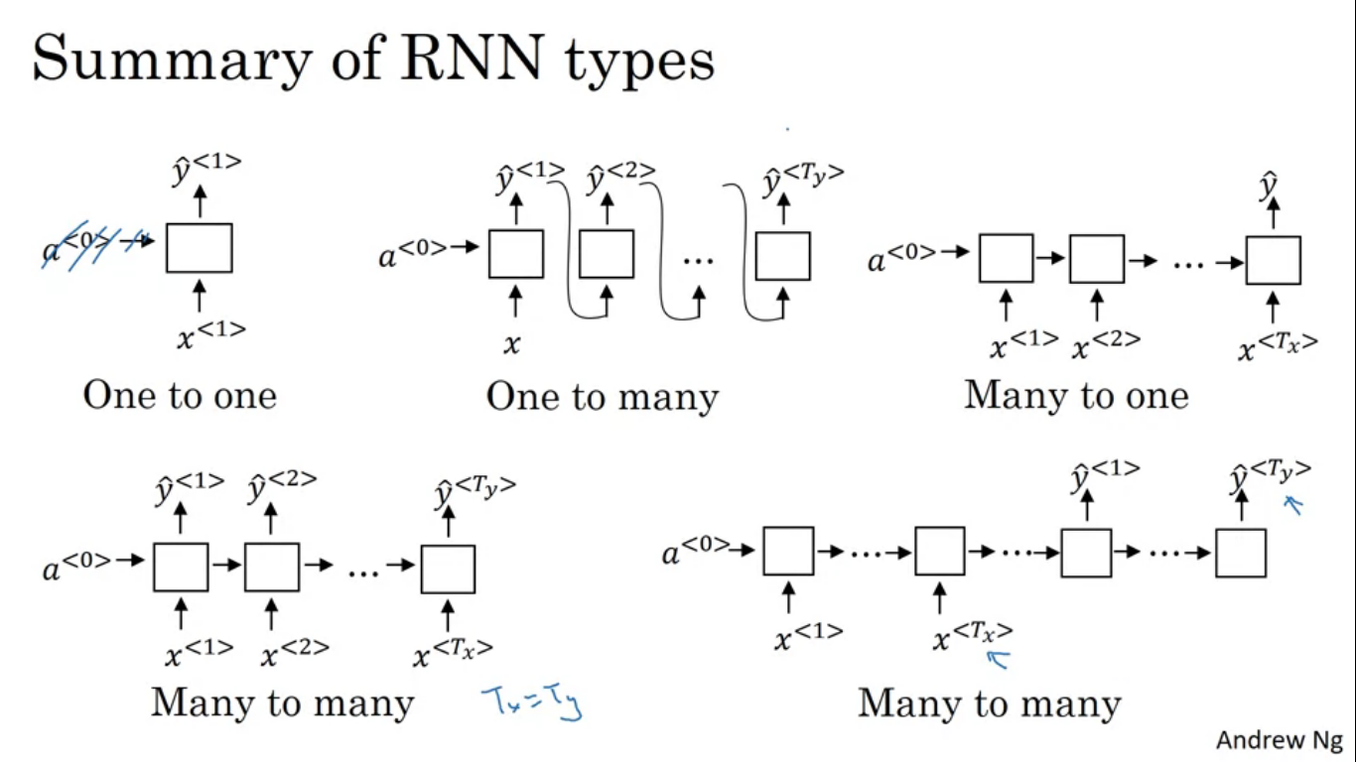

So far we have seen architectures where Tx = Ty, for some applications Tx and Ty may not always be the same. So we can modify the basic RNN structure to address all of these problems.

Many to many architecture – the input sequence has man inputs as sequence and output sequence also has many outputs.

Let’s say we want to address sentiment classification. Here X might be a piece of text and Y may be number either 0 or 1 i.e. a positive review or a negative review or it could be a number from 1-5. So in our architecture rather than having to use an output at every single time step we can have the RNN read the entire sentence and have it output Y at the last time step when it has already input the entire sentence. So this NN would be a many to one architecture.

There is also a one to one architecture like the standard NN.

We can also have one to many architecture. Example of one to many architecture would be music generation. Input X could be just an integer telling the genre or the first note of the music we want.

We take in the first synthesised output and feed it to the next layer as well.

Many to many architecture where the input lengths are different. For an application like machine translation number of words in input and output sentence could be different. So here we have a NN first reading the sentence and having done that we then have the NN output the translation. This NN has two different parts, there is an encoder which takes in an input sentence and then there is a decoder which after reading the sentence outputs the translation in a different language.

**Language Model and Sequence Generation**

Language model is one of the most basic types of NLP.

**What is a language model?**

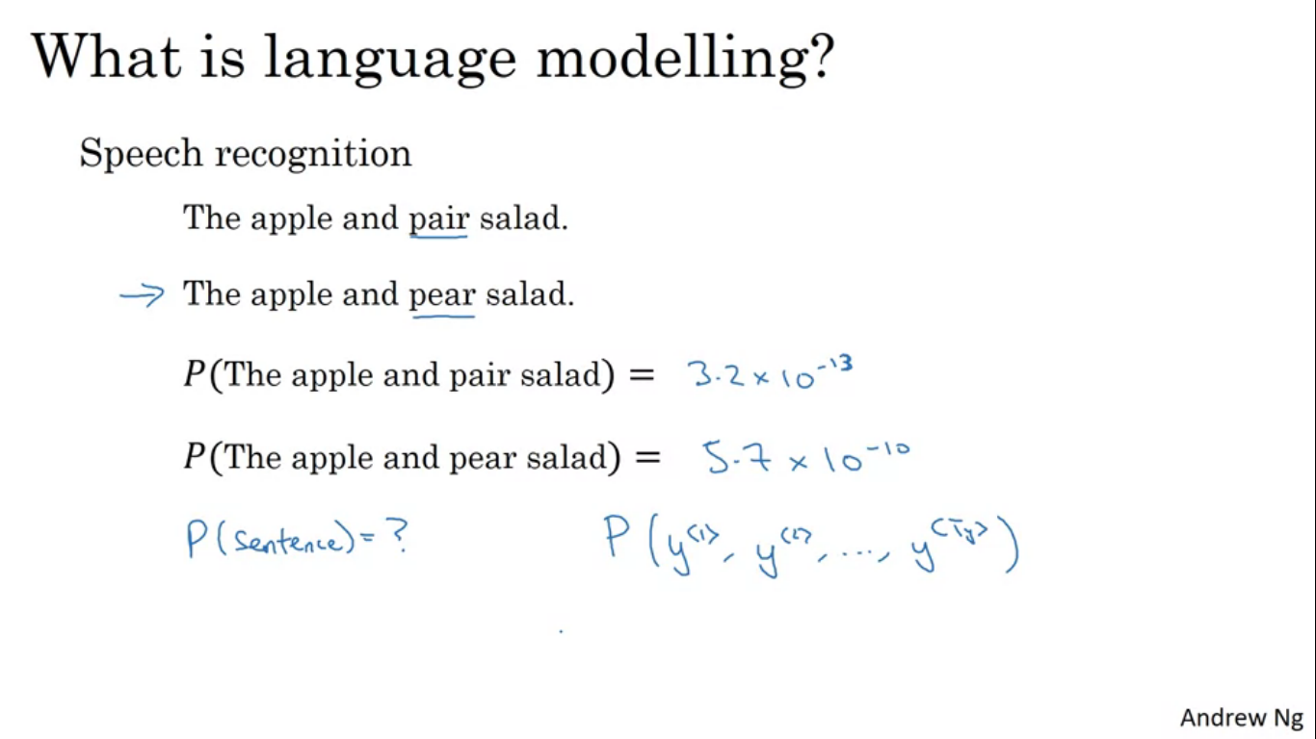

Let’s say we are building a speech recognition system, if we have two sentences that sound exactly the same, a good language model will give us the better generalization of the two sentences. Language model tells the system what is the probability of either of these two sentences. With the probability values the second sentence is much more likely. Given any sentence, the job of the language model is to tell us the probability of the sentence that it would be a particular sentence. This is a fundamental component for speech recognition as well as machine translation system.

The basic job of a language model is to input a sentence which we denote as a sequence Y<1>, Y<2>,.., Y<Ty>. For language model it would be useful to represent the language model as output Y rather than input X. The language model estimates the probability of that particular sequence of words.

**How do we build a language model**

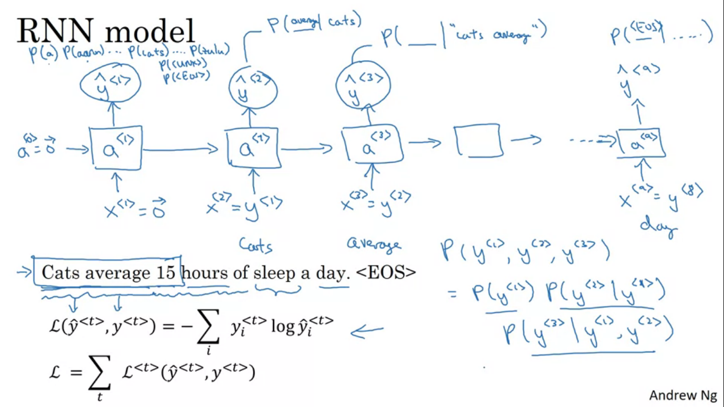

To build a model using RNN we would first need training set comprising a large corpus of English text. Let’s say we get a sentence in training set the first thing we would do is tokenize this sentence and then map each of these words to one hot vectors. When sentences end we want to add an extra token called EOS which stands for end of sentence and it helps to figure out when a sentence ends. EOS token can be appended to the end of every sentence in your training example if we want our models to explicitly capture when sentences end.

**What if some of the words are not in your vocabulary?**

So if your vocabulary has 10000 words the word Mau may not be in our vocabulary, so what we do is we replace the word Mau with a unique token UNK which stands for unknown word and we model the chance of the unknown word instead of specific word.

Tokenization basically means taking the input sentence and mapping it to individual tokens or individual words in your vocabulary.

Next build an RNN to model the chances of these different sequences

A<1> builds to softmax function to figure out what is the probability of the first word Y<1>. This step has a softmax and is trying to predict the probability of any word in the dictionary. P(a), P(aaron), ...P(<EOS>) . So this would be 10000 weight softmax output. Then the RNN steps forward to the next step and has some activation a<2> to the next step and now its job is to figure out what is the second word. But now we would also give it the correct first word so this was X<2>. The RNN’s job is to predict what is the chance of being whatever the word is given what had come previously. Continue with as shown in the image.

So in each step the RNN looks at some set of preceding words such as given the first three wwors what is the distribution over the next word. This RNN learns to predict one word at a time going from left to right. To train this NN we define the cost function. If we train the RNN over large training set , given any initial set of words it can predict what is the chance of next word. Given a new sentence with just three words we see the probabilities as shown.

**Sampling novel sequences**

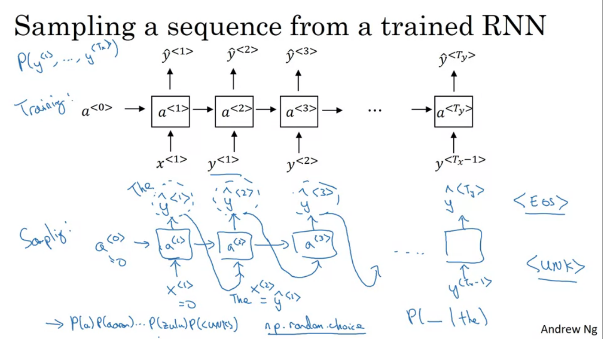

After you train a sequence model, one of the ways to informally get a sense of what is learnt is to have a sample novel sequence. Sequence model models the chance of any particular sequence of words. We want to sample from this distribution to generate novel sequences of words.

First sample what is the first word you want your model to generate. So we input x<1> = 0 and a<0>= 0 and now your first time stamp will have some softmax probability over possible outputs. We then randomly sample according to this softmax distribution. The softmax distribution tells you what is the chance that it refers to the words in the vocabulary. Then we take this vector and use the numpy command np.random.choice to sample according to the distribution defined by this vector probabilities and that lets you sample the first word.

Next go on to the second time step which is expecting this Y<1> as input but we take the Y<1> we had just sampled and pass it as the input to the next timestep. Then this softmax will make a prediction for Y<2>. Then we use the sampling function to sample Y<2> and at the next time step we take whatever choice we had represent it to one hot encoding and pass it to next timestep.

**How do we know we have reached the end?**

If EOS token is a part of vocabulary we can keep sampling until we generate an EOS token which tells us we have hit the end of the sentence and we can stop. Alternatively if we do not have it in thee vocabulary then you can also decide to sample 20/100 or words of your choice and keep going until we have reached that number of time steps. This procedure sometimes will sometimes generate an UNK token , to remove this , reject any sample that came out as UNK and keep resampling from the rest of vocabulary until we get a word that is not an unknown word.

So far we have been building the word level RNN, we can also build character level RNN.

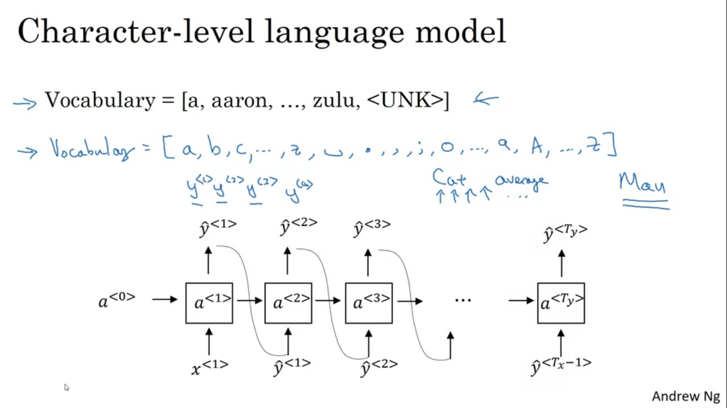

In character level RNN the vocabulary will be just the alphabets, space, punctuation, 0-9. We can also look at the training set corpus and look the characters that appear there and use that to define the vocabulary. In character level language model then the sequence Y<1>,Y<2>,Y<3> would be individual characters in training data rather than individual words in the training data.

Using a character level language model has some pros and cons. One is that you don’t have to worry about unknown word tokens. A character level language model can assign a word like mau a non zero probability. Whereas in word level language model, for mau, we had to assign the UNK token. Main disadvantage is that you end up with a much longer sequence, many English sentences will have 10-20 words but may have, many dozens of characters. So character level model is not as good as word level in capturing long range dependencies between how the earlier part of sentences affect the later part of sentences. Character level are more computationally expensive to train.

**Vanishing Gradients Problem in RNN**

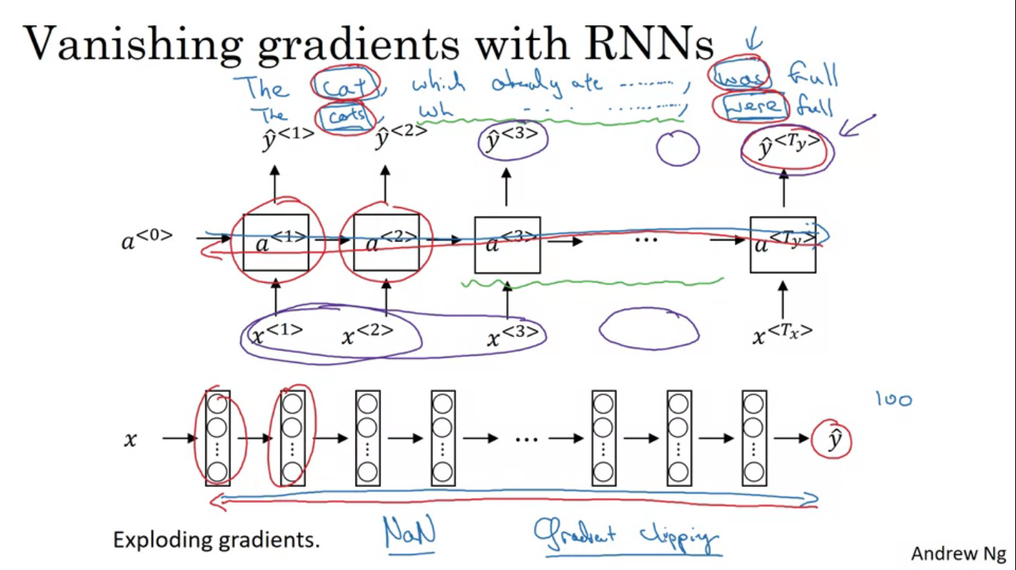

As we see in the example – cat ->> was and cats- >> were, one example where we can have a very long term dependency where a word which comes much earlier can affect a word which comes much later in the sentence. Basic RNN we have seen is not very good at capturing long term dependencies.

In very deep networks the gradient from the output Y would have a very hard time propagating back to affect the weights of these earlier layers. In RNN it can be difficult for the outputs of the errors associated with the later time steps to affect the computations that are earlier. So we need to memorize stuff from the starting layers from a very long time before we get to use that bit of information.

The basic RNN model has many local influences, meaning output Y<3> is influenced by values close to Y<3>, so an output in the further right side will not be very much influenced by the input early in the sequence. It is very difficult for the error to back propagate to the beginning of the sequence.

The exploding gradients are easier to spot since the parameters just blow up leading to result of numerical overflow in NN. Even if we do see exploding gradients , one solution to that is gradient clipping. Look at the gradient vectors and if they are bigger than some threshold rescale some of the gradient vectors so that it is not too big.

**GRU (Gated Recurrent Unit)**

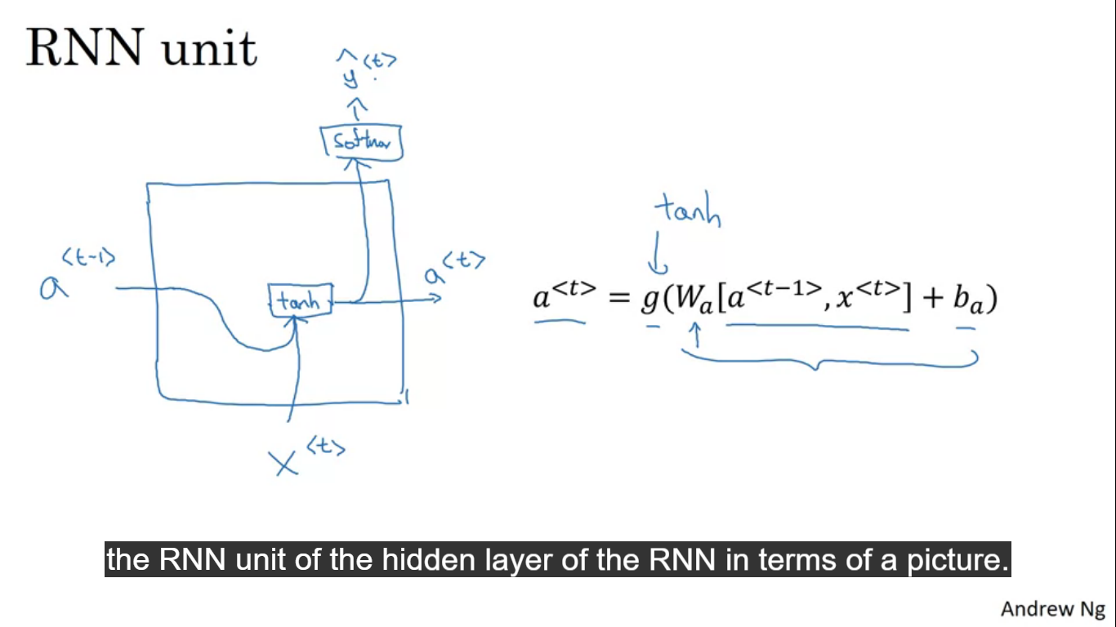

It is a modification to RNN hidden layer that makes it much better at capturing long range connections and helps a lot with the vanishing gradients problem.

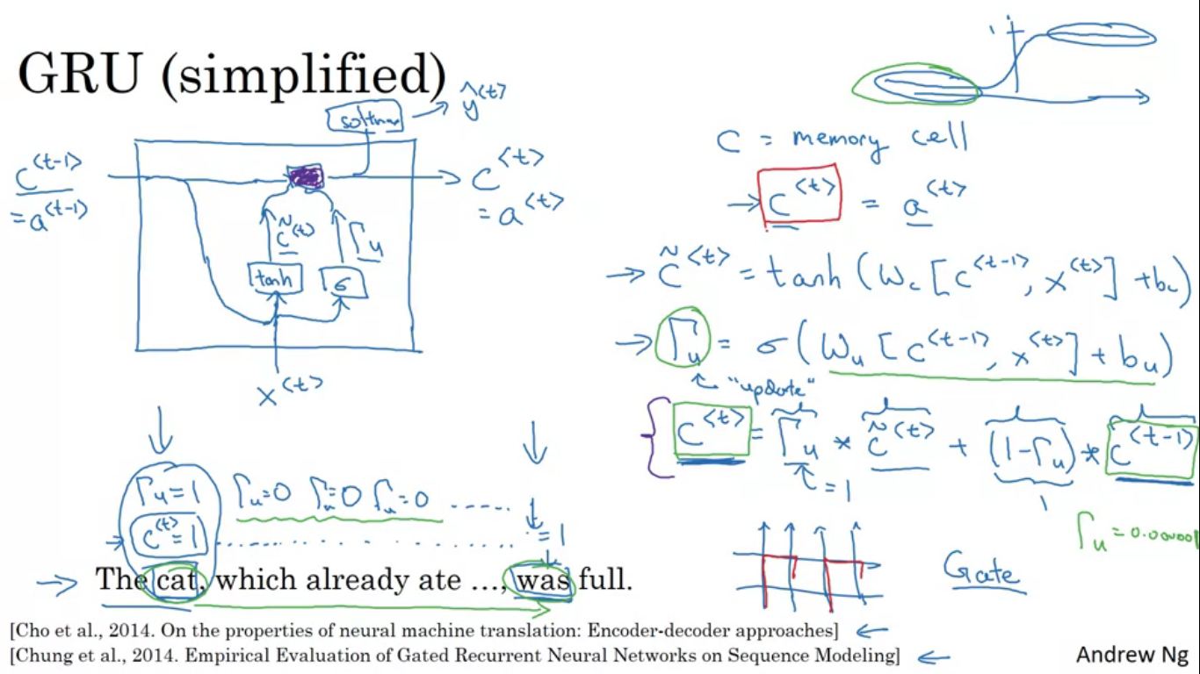

GRU unit has a new variable called c which stands for memory cell. It will provide memory to remember whether was cat was singular or plural. And when it gets further in the sentence it can remember whether the subject of the sentence was singular or plural.

So c<t> = a<t>

At every time step we are going to consider over writing the memory cell with the value c~<t> . its equation is as shown.

The key idea of the GRU is that we have a gate, its called gammaU, where U stands for update gate and this will be a value between 0 and 1.

So we have come up with a condition to whther update c with c~ and the gate gammaU decides whether or not we actually update it. The memory cell c is going to be set to 1/0 depending upon the word we are considering is singular or plural. So for singular it is 1 and for plural it is set to 0.

Then the GRU unit will memorize the value of c, job of the gate gammaU is to decide when do you update these values. So according to the equation of c<t>, if the gammaU = 1 then set the new value of c<t> to c~<t> and if gammaU = 0 then it is setting c<t> to the old value. This does not suffer from the problem of vanishing gradients because the value of c<t> will be defined for many many time steps. Therefore it also helps NN to go on a very long range dependency.

C<t> and c~<t> would be same dimension and gammaU is also the same dimension, in that case the * is element wise multiplication. It tells the GRU which are the dimensions in your memory cell vector to update at every time step. So we can choose to keep some bits constant while updating other bits.

For the full GRU unit we have gammaR where R is there for relevance

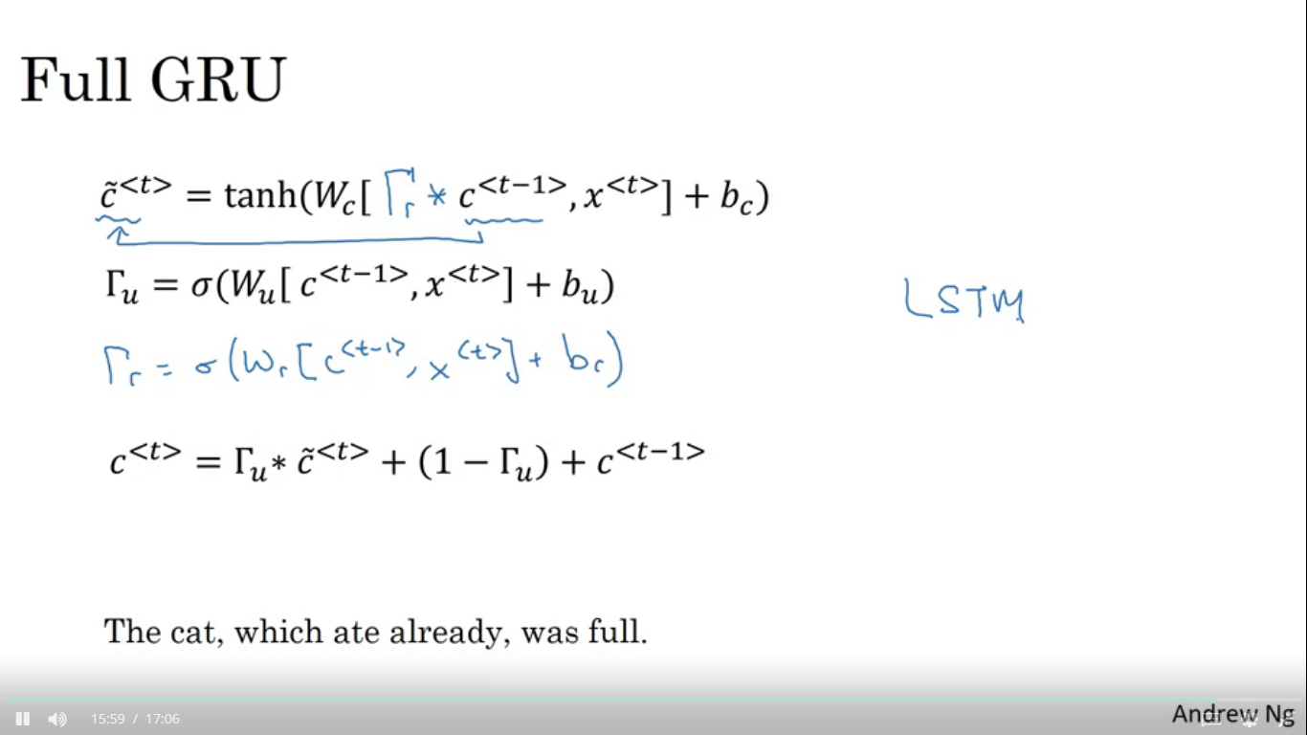

**LSTM (Long Short Term Memory)**

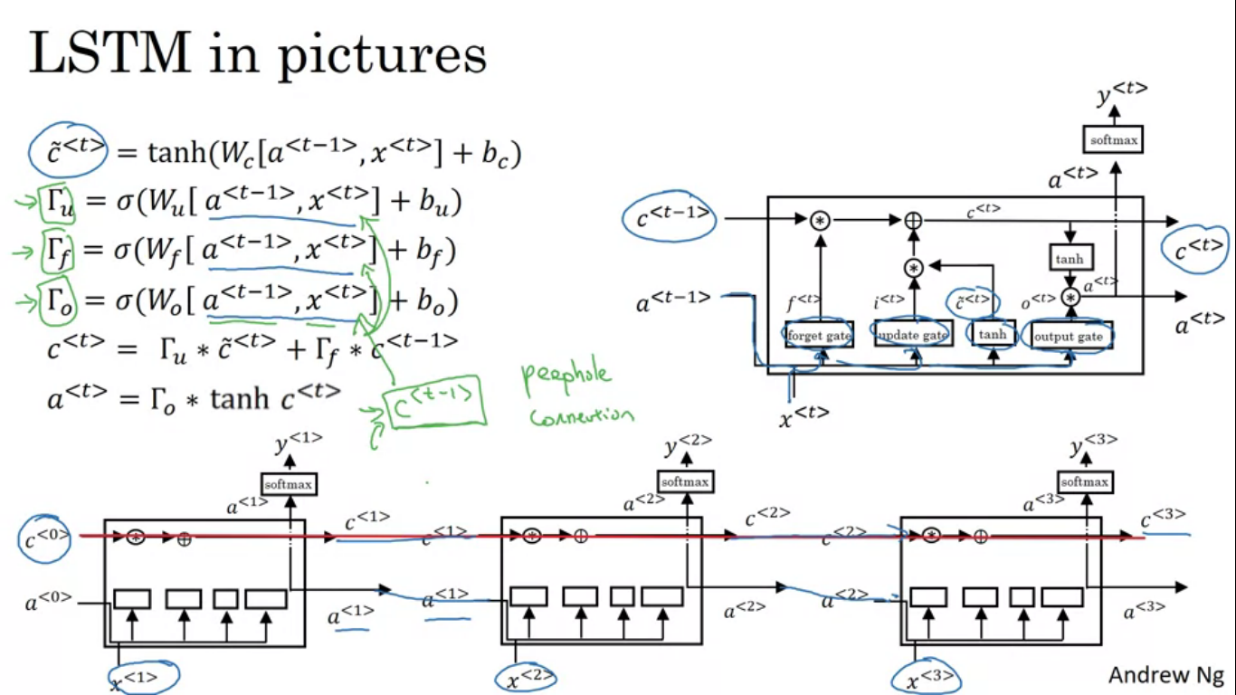

Instead of having 1 update gate control c<t> we are going to have two separate terms. This gives the memory cell the option of keeping the old value c<t-1> and just adding to it the new value of c~<t>. LSTM has three gates while GRU has 2. LSTM has update, forget and output gate. So a value can be passed all the way to the right and that is why LSTM is good at memorizing certain values even for a long time.

Peephole connection the gate values are dependent on a<t-1>, x<t>, c<t-1>.

**Bi-Directional RNN**

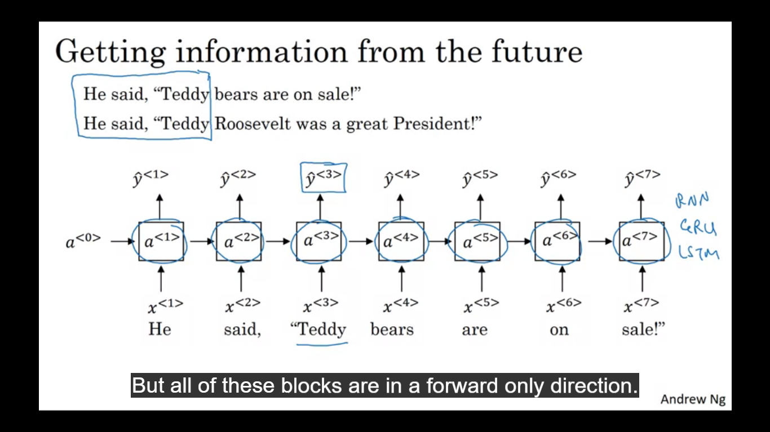

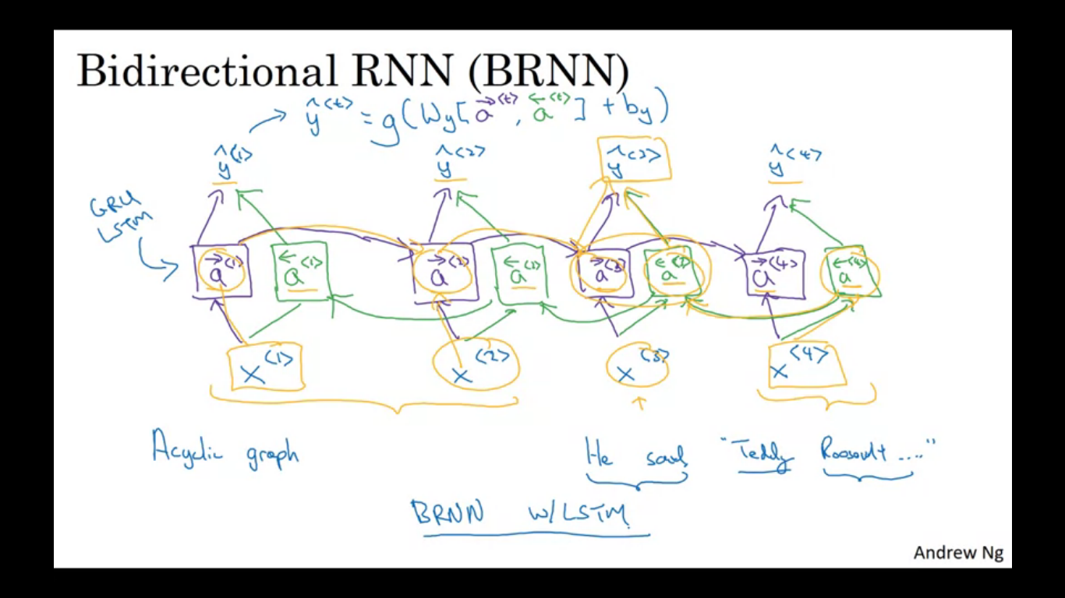

It lets us to take information from both earlier and later in the sequence. The word teddy is used as a name can’t be determined by looking at just first three words. The image has the blocks which could either be a RNN,LSTM,GRU but are implemented in a forward direction only. The backward connections will be connected to each other going backward in time. So in forward prop the forward sequence computes a forward 1,2,3,4 and the backward sequence would start by backward 4,3,2,1 to compute network activation. Forward prop has computation going from left to right and from right to left in this diagram. To make the prediction it is both directions. To compute y<3> the path is shown in the orange ink. So it has information from the past as well as information from the future.

NLP problems BRNN with LSTM are more commonly used.

**Deep RNNs**

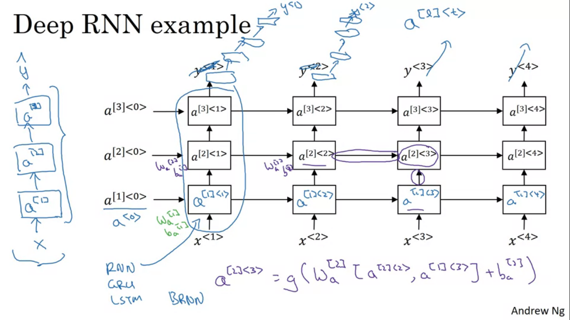

To build very complex functions it is sometimes useful too stack the layers of RNN together to build deeper versions of these models. The added square bracket shows for the numbered layer.

For RNN having three layers is already quite a lot because of having the temporal dimension these networks can get quite big even if we have just small handful of layers

Recurrent layers stacked on top of each other